**INFORMATION SECURITY MANAGEMENT (CSE 3502)**

**LAB-1**

**Name: Bhagath Singh.B**

**Reg.No. 17MIS1043**

**Faculty: Dr.Anusha K**

**Designing Network Topology Layout in Cisco Packet Tracer:**

**The main steps are:**

* **Configuring the topology**
* **Interfacing the topology**
* **Using corresponding protocol required**
* **Verifying the network connection between the source and destination.**

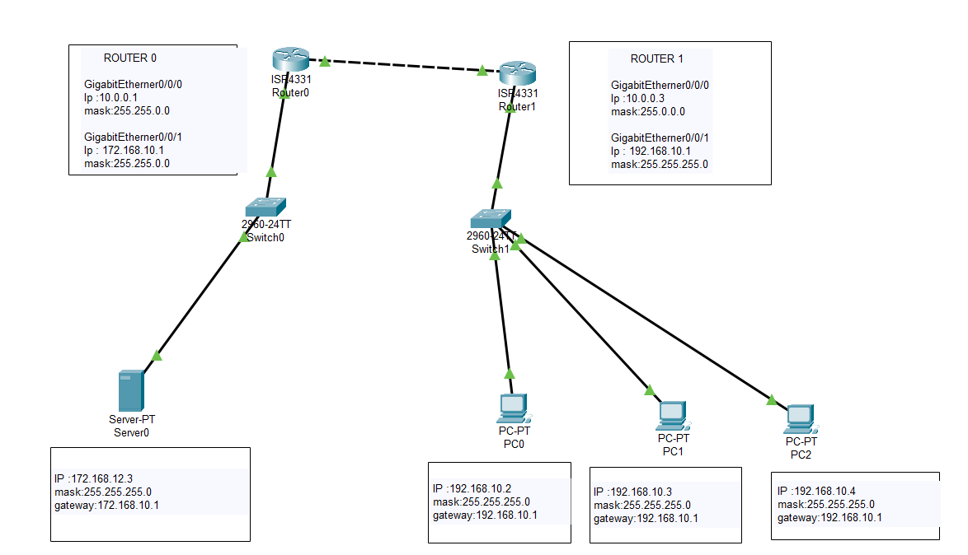

**Initial Output: Successful transfer of packets from Server to PC**

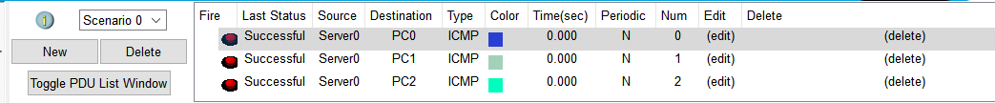

**STANDARD ACL:**

**Commands for Standard ACL Execution: In the router terminal (CLI)**

* **Here we are blocking the IP address 192.168.10.4**
* **Using access list we block the require IP address**
* **The standard access lists range from 1-99 and 1300-1999**

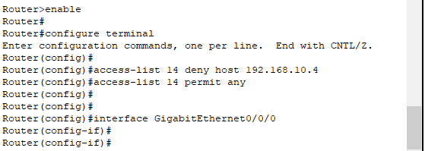

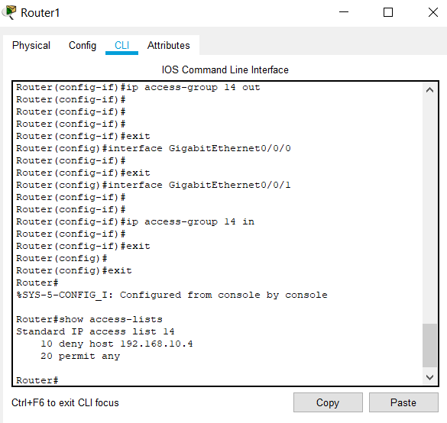

**Procedure:**

* **Select an IP address of a particular PC to block it from the network.**
* **Then inbound and the outbound connections of router must be configured.**
* **Then exit from the terminal and send the packets from the server to the blocked IP address then we can notice the failed package transfer.**

**Output after Standard ACL execution:**



**Conclusion:**

**The PC 2 is blocked from receiving the packets which we can see in the output window.**

**EXTENDED ACL:**

**Commands for Standard ACL Execution: In the router terminal (CLI)**

* **Here we are blocking the IP address 192.168.10.4 and server IP address 172.168.12.3**
* **In the extended ACL we filter the packets with respect to source and receiver side.**
* **Using access list we block the require IP address**
* **The extended access lists range from 100-199 and 2000-2699**

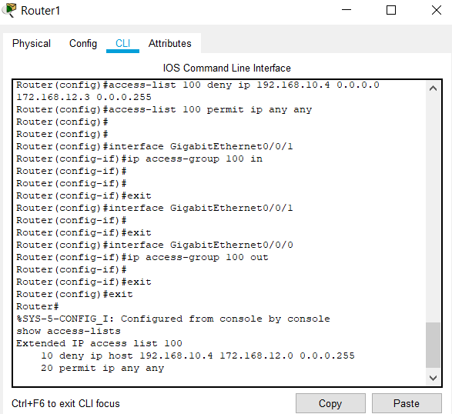

**Procedure:**

* **Select an IP address of a particular PC to block it from the network and also the server IP address to block the packets from.**
* **Then inbound and the outbound connections of router must be configured.**
* **Then exit from the terminal and send the packets from the server to the blocked IP address then we can notice the failed package transfer.**

**Output with Extended ACL execution:**

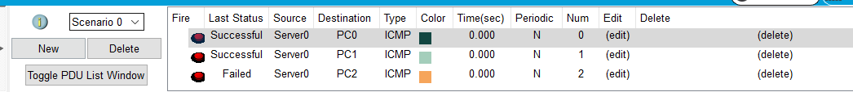

**Conclusion:**

**The PC 2 is blocked from receiving the packets which we can see in the output window.**